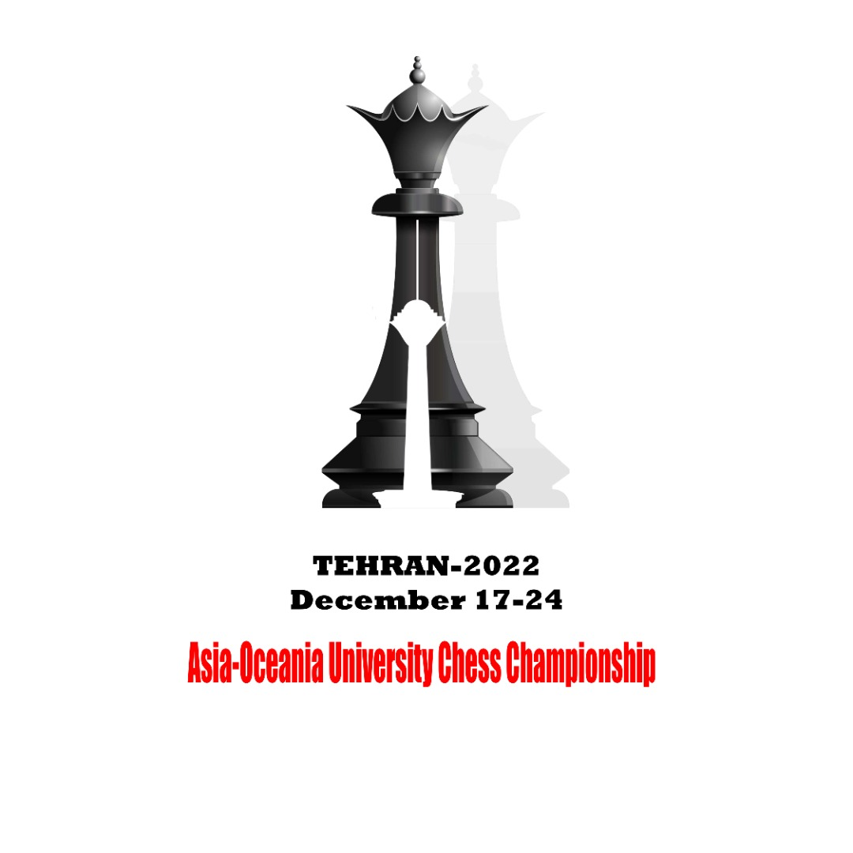 | 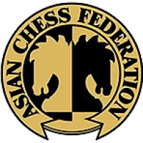

2022 Asia-Oceania University Chess Championship
Online, December 17th to 26th

OC Email: Irannusf@yahoo.com, Tel:+982188915251-3, Fax: +982188808732

Individual Entry Form
(Players)

I1

Country/Region : |  | Country Code

 | Last Name |  |  | First Name |  |  | Passport/ID photo less than 50 KB
Roman Alphabet
Date of Birth |  |  |  | Place of Birth
 | Year | Month | Day | Participant must be born from 1st January 1994 to 31st December 2004
Passport/ID Number |  | FIDE ID
Name of University
Field of Study |  | Year of Study |  | Graduation Date
Tornelo Username |  | FIDE Rapid rating

By participating or otherwise appearing in an AUSF event, each competitor, participant, official and each officer, agrees to be filmed, televised, photographed, identified and otherwise recorded, under the conditions and for the purposes authorised by AUSF either currently or in the future, and in relation to the promotion of the Sporting, Cultural, and Educational activities organised under the aegis of AUSF or under its patronage.

I declare that the above athlete is a bona fide member of the delegation participating in the 2022 Asia-Oceania University Chess Championship, that the information stated on this form is true to the best of my knowledge.

Entry to be sent back no later than 17th, November 2022
The digital entry must be sent to the Organizing Committee (Irannusf@yahoo.com), and copied to AUSF (ausf@ausf.org)
Please keep a copy for your own records.

Name and Signature of the President or Secretary General of the NUSF
Name |  | Function |  |  |  |  |  |  |  | Seal  NUSF
Signature |  | Date
CIC Approval |  |  | 2022 | CIC | Category

For Official Use Only
Asian University Sports Federation
33-2, Ronghuiyuan, Yuhua Road, Shunyi District, Beijing, China
Tel: (86) 10 66093760, Fax: (86) 10 66093766
E-mail:ausf@ausf.org,http://www.ausf.org

