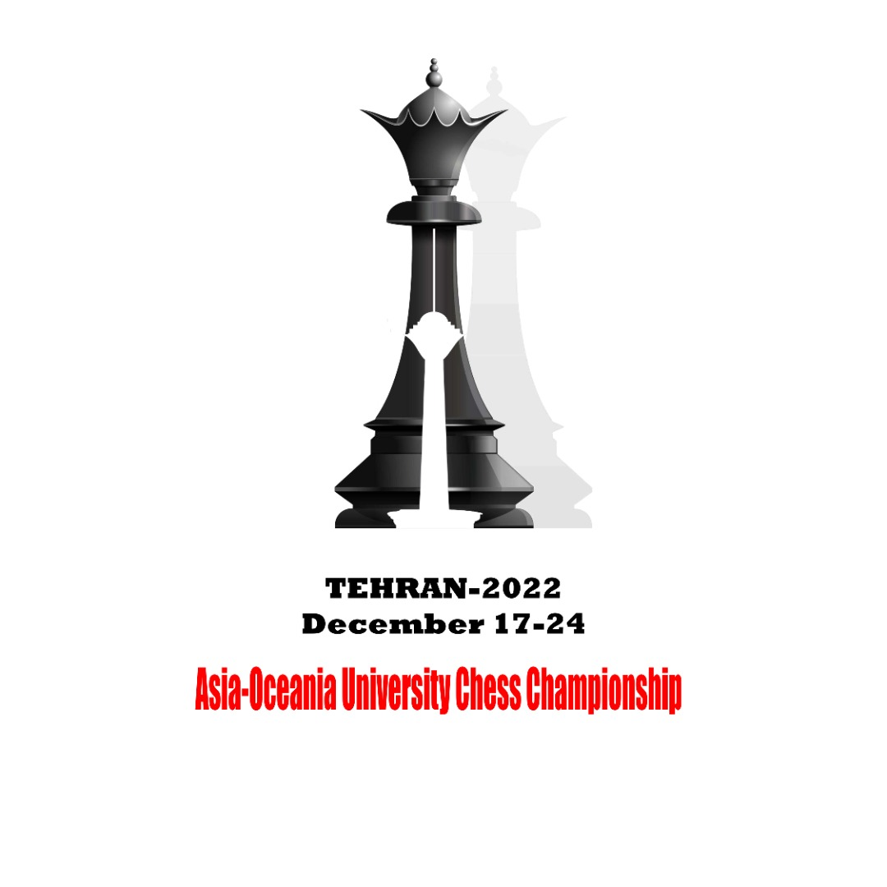 | 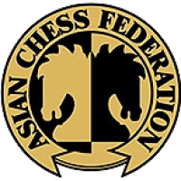

2022 Asia-Oceania University Chess Championship
Online, December 17th to 26th

OC Email: Irannusf@yahoo.com, Tel:+982188915251-3, Fax: +982188808732
Individual Entry Form
(Officials)

I2

Country/Region : |  | Country Code

 | Last Name |  |  | First Name |  |  |  |  | Passport/ID photo less than 50 KB
Roman Alphabet
Nationality |  |  |  |  | Sex | M | F
Date of Birth |  |  |  | Place of Birth
 | Year | Month | Day

Passport/ID Number
Address
City |  | Whatsapp |  | Country/Region
Phone |  | Fax |  | Email
Please check one of the following functions:
Head of Delegation | A |  |  | Team Leader | E |  |  | Physician | I
Deputy Head of Delegation | B |  |  | Team Official | F |  |  | Medical Personnel | J
Secretary | C |  |  | Technician | G |  |  | Media Liaison | K
Delegation Official | D |  |  | Coach | H |  |  | Other | L

By participating or otherwise appearing in an AUSF event, each competitor, participant, official and each officer, agrees to be filmed, televised, photographed, identified and otherwise recorded, under the conditions and for the purposes authorised by AUSF either currently or in the future, and in relation to the promotion of the Sporting, Cultural, and Educational activities organised under the aegis of AUSF or under its patronage.

I declare that the above athlete is a bona fide member of the delegation participating in the 2022 Asia-Oceania University Chess Championship, that the information stated on this form is true to the best of my knowledge.

Entry to be sent back no later than 17th, November 2022
The digital entry must be sent to the Organizing Committee (Irannusf@yahoo.com), and copied to AUSF (ausf@ausf.org)
Please keep a copy for your own records.
Name and Signature of the President or Secretary General of the NUSF
Name |  | Function |  |  |  |  |  |  |  | Seal
Signature |  | Date
CIC Approval |  |  | 2022 | CIC | Category

For Official Use Only
Asian University Sports Federation
33-2, Ronghuiyuan, Yuhua Road, Shunyi District, Beijing, China
Tel: (86) 10 66093760, Fax: (86) 10 66093766
E-mail:ausf@ausf.org,http://www.ausf.org

