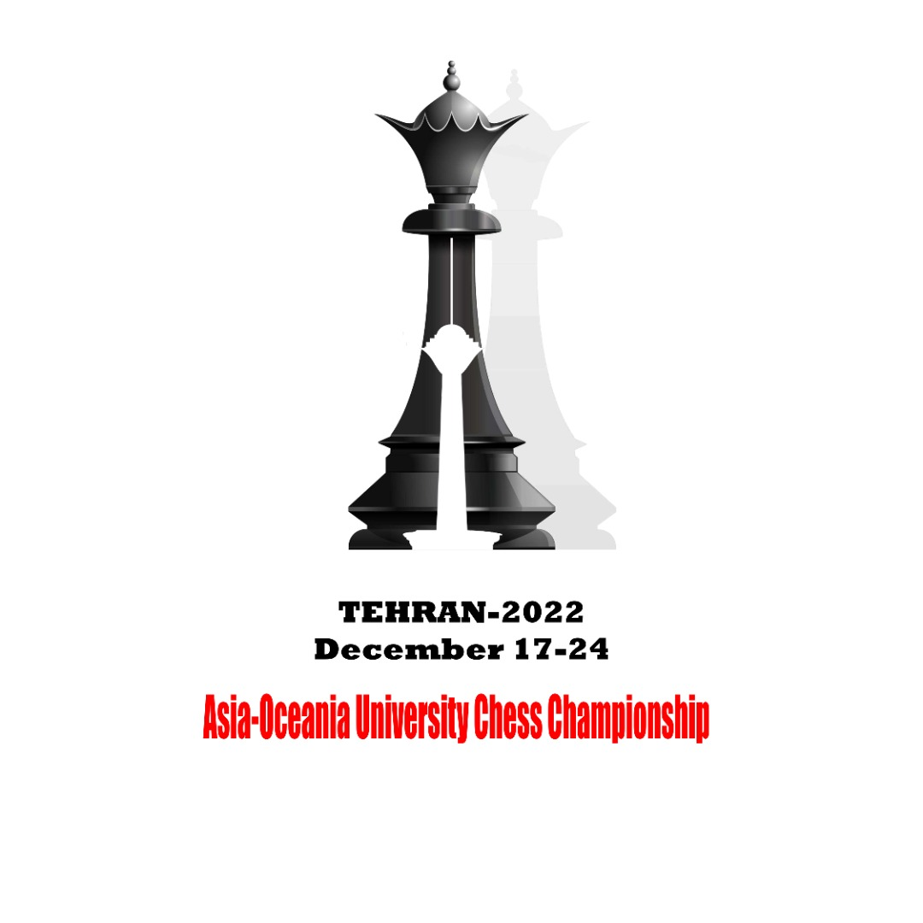 | 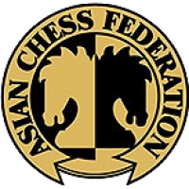 | 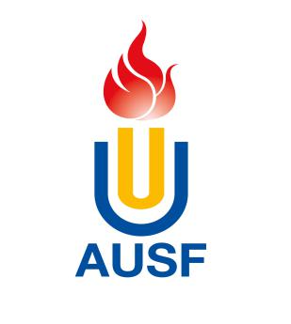
2022 Asia-Oceania University Chess Championship
Online, December 17th to 26th

OC Email: Irannusf@yahoo.com, Tel:+982188915251-3, Fax: +982188808732

Academic Eligibility
Country/region |  | Country Code
Name of NUSF:
To be completed by player
Last Name
First Name
Nationality
Date of birth
Name of University
Faculty/School
I certify to the best of my knowledge that the above Academic Record is correct.
To be completed by the University or Educational Authority
Name and Signature of University or Educational Authority Representative

Name

Official Seal

Signature_

Date

To be completed by NUSF
Name and Signature of the NUSF President or Secretary General

Official Seal

Name

Signature_

Date
WARNING
The information given above must be accurate and to the best of the signatories’ knowledge at the date indicated below. Any false information will lead to disqualification. Should any information change, please inform immediately.

AUSF Regulations
Participation
Only competitors who meet the following conditions may take part in the event:
a) be full-time students who are currently officially registered as proceeding towards a degree or diploma at the university or similar institute whose status is recognized by the appropriate national academic authority of their country or regions;
b) be former students who have obtained their academic degree or diploma in the preceding year;
c) be at least 17 and less than 28 years of age on January 1st in the year of the AUCC (born from 1st January 1994 to 31st December 2004).

For Official Use Only
Asian University Sports Federation
33-2, Ronghuiyuan, Yuhua Road, Shunyi District, Beijing, China
Tel: (86) 10 66093760, Fax: (86) 10 66093766
E-mail:ausf@ausf.org,http://www.ausf.org

